**Exercise 5: Bootstrap 5**

Objectives and Outcomes

This exercise introduces the first set of steps to set up your web page to make use of Bootstrap classes and components. By the end of this exercise, you will be able to:

* Download Bootstrap using NPM and include it in your project
* Understand how to set up a web project to use Bootstrap
* Include the Bootstrap CSS and JS classes into a web page

Downloading Bootstrap

* You will use npm to fetch the Bootstrap files for use within your project. Thereafter you need to install JQuery and Popper.js as shown below since Bootstrap 5 depends on these two. At the prompt, type the following to fetch Bootstrap files to your project folder:

npm install bootstrap

npm install jquery

npm install popper.js --save

* This will fetch the Bootstrap files and store is in your node_modules folder in a bootstrap folder. The bootstrap->dist folder contains the precompiled Bootstrap CSS and JS files for use within your project.
* Open your project folder in your editor, and then open the index.html file in the conFusion folder. This is your starting web page for the project. We have already created the web page with some content to get you started. We will use Bootstrap to style this web page, and learn Bootstrap features, classes and components along the way.
* Start your lite-server by typing **npm start** at the prompt. The index.html file should now be loaded into your default browser.

Getting your Web page Bootstrap ready

* Open the index.html file in your favourite text editor. If you are using Visual Studio Code, Brackets, Sublime Text or similar editors, you can open the project folder in the editor and then view index.html.
* Insert the following code in the <head> of index.html file before the title.

<meta charset="utf-8">

    <meta name="viewport" content="width=device-width, initial-scale=1, shrink-to-fit=no">

    <!-- Bootstrap CSS -->

    <link rel="stylesheet" href="node_modules/bootstrap/dist/css/bootstrap.min.css">

* This will include Bootstrap CSS into your web page. Note the subtle change in the fonts of the content of the web page. This is the Bootstrap typography effect coming into play. The default Bootstrap typography sets the font to Helvetica Neue and selects the appropriate font size based on the choice of the heading style and paragraph style for the content.
* At the bottom of the page, just before the end of the body tag, add the following code to include the JQuery library, popper.js library and Bootstrap's Javascript plugins. Bootstrap by default uses the JQuery Javascript library for its Javascript plugins. Hence the need to include JQuery library in the web page.

 <script src="node_modules/jquery/dist/jquery.slim.min.js"></script>

* Now, do a Git commit with the message "Intro. to Bootstrap". You may push the commit to your online repository.

Exercises

1. Create website with bootstrap 5 as image below

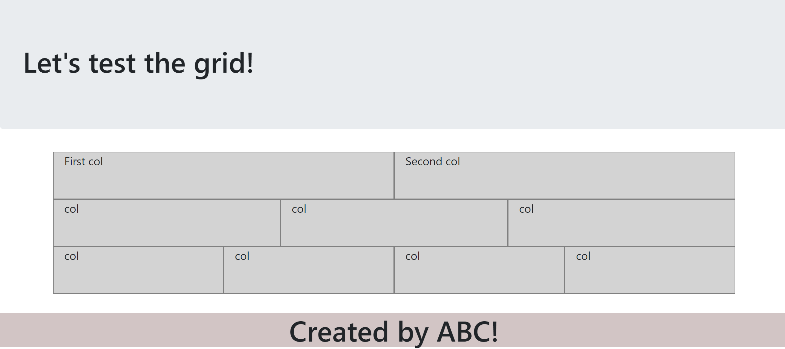

1. Create website with bootstrap 5 as image below

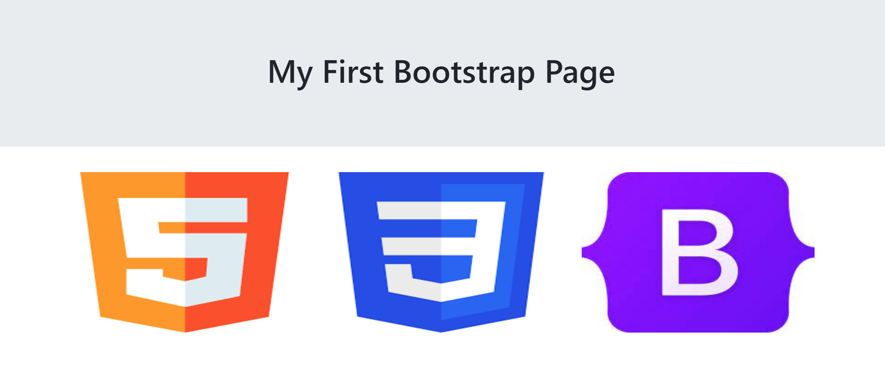

1. Create website with bootstrap 5 as image below

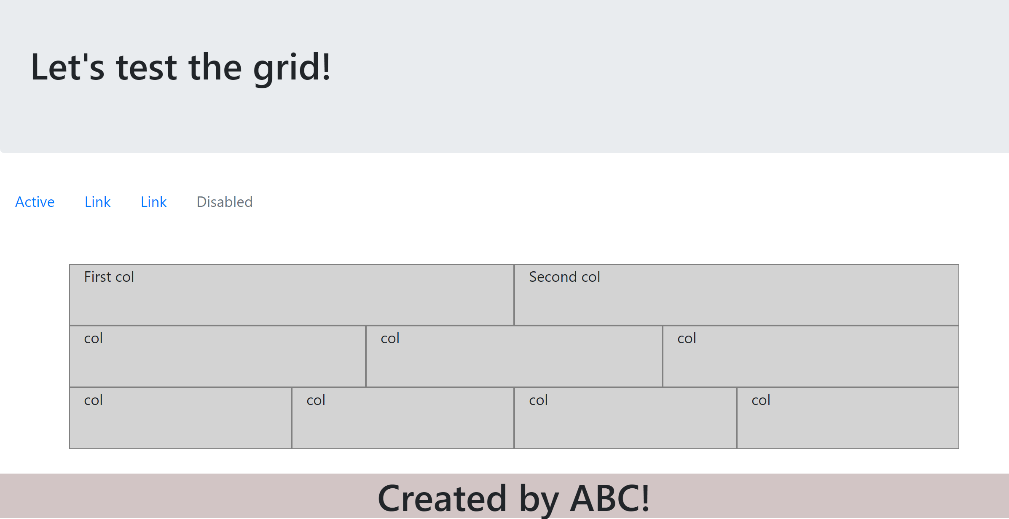

1. Create website with bootstrap 5 as image below



1. Create website with bootstrap 5 as image below

**

Conclusion

After learning Bootstrap 5, you should have gained a solid understanding of the framework and its various components and features.